Predicting Amazon Product Sales Volume: A Gaussian Process Regression and Classification Approach.
Task-1: The Machine learning algorithms for solving real-world problems in Regression, Classification, modelling data, and text mining.
- Abstract:
This study investigates the prediction of Amazon product sales volume, a critical task for inventory management and marketing optimization, using Gaussian Process Regression (GPR) and Classification (GPC). The methodology encompassed data cleaning, feature engineering including the creation of price discount and delivery time and the application of GPR to predict continuous sales volume and GPC to classify sales volume into distinct categories. GPR, intended for continuous prediction, yielded an R-squared of -0.685, indicating a limited capacity to explain variance in sales volume. Conversely, GPC achieved a classification accuracy of 0.556, suggesting moderate success in categorizing sales volume. Based on these performance metrics, GPC demonstrated a marginally better, albeit still limited, capability in modeling sales volume patterns within this dataset. Consequently, further research focusing on enhanced feature engineering, alternative modeling techniques, and expanded datasets may be necessary to significantly improve sales volume prediction accuracy and reliability.
2. Introduction
2.1. Problem Statement: Predicting Amazon Product Sales Volume
The e-commerce landscape is rapidly evolving (Bishop, 2006), with Amazon at its forefront. Accurate sales volume prediction has become a critical challenge for businesses operating on this platform. (SEEGER, 2004) This study focuses on forecasting sales volume for Amazon-listed products, a task of paramount importance for sellers aiming to optimize inventory, streamline operations, and make data-driven marketing decisions.
The complexity of the Amazon marketplace, with its vast array of products, dynamic pricing, and ever-changing consumer behavior (Aggarwal, 2018), makes sales prediction a formidable challenge. Traditional forecasting methods often fall short in capturing the intricate relationships between various factors influencing sales. (Williams, 2007) This research leverages advanced machine learning techniques, specifically Gaussian Process Regression (GPR) and Classification (GPC), to improve prediction accuracy and provide valuable insights for enhancing competitiveness and profitability in the online marketplace.
2.2. Literature Review: Existing Research on Sales Forecasting in E-commerce
E-commerce sales forecasting has been a subject of extensive research, with methodologies evolving alongside technological advancements. Time series analysis, including ARIMA models and exponential smoothing methods, has been widely used to identify patterns and trends in historical sales data. These techniques have proven effective for short-term forecasting but often struggle with the volatility and seasonality inherent in e-commerce sales.
Regression models have been employed to capture the relationship between sales volume and various (Pal, 2024) influencing factors such as price, promotions, and seasonality. However, these traditional methods often fail to capture the complex, non-linear relationships that characterize the e-commerce environment. The dynamic nature of online marketplaces, with rapid changes in consumer preferences and market conditions, poses significant challenges to conventional forecasting techniques (Wang &; Aviles, 2022).
Machine learning approaches have emerged as promising alternatives, offering the ability to model intricate patterns and handle large, multidimensional datasets (Sharma et al., 2019). These techniques can adapt to changing market conditions and capture complex interactions between variables, potentially leading to more accurate and robust sales predictions.
2.3. Related Work: Regression and Machine Learning Techniques for Sales Volume Prediction
Recent studies have explored various machine learning techniques for e-commerce sales prediction. Support Vector Machines (SVMs) have been applied to model non-linear relationships between product features and sales performance, demonstrating improved accuracy over linear regression models. Random Forests have shown promise in handling high-dimensional data and capturing complex interactions between variables (Rivera &; Burnaev, 2017).
Deep learning models, particularly neural networks, have gained traction in sales forecasting due to their ability to capture long-term dependencies and complex patterns in time series data. However, these models often require large amounts of training data and can be computationally expensive (Shimizu et al., 2015). Additionally, the lack of interpretability in deep learning models can make it challenging to understand the factors driving sales predictions, a crucial consideration for business decision-making.
2.4. Suitability of Gaussian Process Regression and Classification
Gaussian Process Regression (GPR) and Classification (GPC) offer a unique approach to sales volume prediction by explicitly modeling uncertainty. GPR is particularly well-suited for capturing non-linear relationships between product features and continuous sales volume, while providing confidence intervals for predictions. This ability to quantify uncertainty is crucial in the volatile e-commerce environment, where numerous factors can influence sales outcomes.
GPC extends the Gaussian Process framework to classification problems, allowing for the categorization of sales volume into distinct levels (e.g., low, medium, high). This approach can be particularly useful for strategic decision-making, such as inventory management and marketing resource allocation.
These techniques are advantageous when dealing with limited data or when uncertainty quantification is critical for decision-making. By leveraging the strengths of GPR and GPC, this research aims to provide accurate and reliable sales volume predictions for Amazon products, while also offering insights into the factors driving sales performance. The probabilistic nature of these models aligns well with the uncertainties inherent in e-commerce sales forecasting, making them promising candidates for improving prediction accuracy in this domain.
3. Problem and Dataset Description:
3.1. Problem Definition:
This study addresses the problem of predicting the sales volume of products listed on Amazon. Sales volume, in this context, refers to the estimated number of units purchased within a specific timeframe, as indicated by the "sales_volume" column in the dataset. The values are represented as a range (e.g., "6K+ bought in past month"), signifying that at least 6,000 units were sold. Accurately predicting sales volume is crucial for effective inventory management, supply chain optimization, and marketing strategy development for sellers on the Amazon platform.
However, accurately forecasting sales volume presents significant challenges. Seasonality plays a major role, with certain products experiencing higher demand during specific periods, such as holidays or back-to-school season. Competition from other sellers offering similar products can also impact sales volume. External factors, such as economic conditions, changes in consumer preferences, and even unexpected events (e.g., viral social media trends), can introduce volatility and uncertainty.
To address these challenges and improve prediction accuracy, this research utilizes machine learning techniques. Machine learning models can learn from historical data, identify patterns, and adapt to changing conditions, enabling more accurate and robust sales forecasts. By incorporating relevant product features, such as price, ratings, and reviews, these models can capture the complex relationships that drive sales volume. Ultimately, the goal is to develop a predictive model that provides valuable insights for sellers to make informed decisions and optimize their business strategies on Amazon.
3.2. Dataset Description:
The dataset used in this study consists of 64 observations (rows) and 22 features (columns) representing a variety of products listed on Amazon. The dataset includes a mix of numerical, categorical, and boolean data types.
- Key Features:
- asin: (Object) The Amazon Standard Identification Number, a unique identifier for each product.
- product_title: (Object) The name or title of the product.
- product_price: (Object) The current price of the product, presented as a string with currency symbols. This needs to be cleaned and converted to a numerical data type.
- product_original_price: (Object) The original or list price of the product, also presented as a string with currency symbols. This also needs cleaning and conversion. Missing values are present in this column.
- currency: (Object) The currency in which the product price is listed (e.g., USD).
- product_star_rating: (Float64) The average star rating of the product based on customer reviews. Missing values are present in this column.
- product_num_ratings: (Int64) The number of ratings or reviews the product has received.
- sales_volume: (Object) An estimate of the number of units bought in the past month. This is represented as a string (e.g., "6K+ bought in past month") and requires cleaning and conversion to a numerical data type. Missing values are present in this column.
- is_best_seller: (Bool) A boolean value indicating whether the product is a best seller.
- is_amazon_choice: (Bool) A boolean value indicating whether the product is an Amazon's Choice product.
- is_prime: (Bool) A boolean value indicating whether the product is eligible for Amazon Prime shipping.
- climate_pledge_friendly: (Bool) A boolean value indicating whether the product is part of Amazon's Climate Pledge Friendly program.
- delivery: (Object) Delivery information and date.
- has_variations: (Bool) Indicates whether the product has variations (e.g., different colors or sizes).
- Data Quality Issues and Preprocessing Steps:
The dataset exhibits several data quality issues that required preprocessing. As revealed by the initial data inspection (using head(), info(), describe(), and isnull().sum()), missing values were present in the product_original_price, product_star_rating, and sales_volume columns. To address this, missing numerical values were imputed with the mean of their respective columns. The sales_volume column required significant cleaning to remove non-numeric characters and convert the values to a numerical format, filling remaining NaN values with 0.
The product_price and product_original_price columns were initially stored as objects (strings) due to the presence of currency symbols. These columns were cleaned by removing the currency symbols and converting them to numerical data types.
These data cleaning and preprocessing choices were made to ensure the data was suitable for machine learning modeling. Imputing missing values with the mean is a common technique that preserves the overall distribution of the data. Converting data types to their appropriate formats is essential for accurate model training and prediction. The features used for modeling are selected based on the relevance to the prediction task. Columns with predominantly missing values (e.g., product_availability, unit_price, unit_count) were not considered.

4. Methods
4.1. Data Preprocessing:
The initial dataset required several preprocessing steps to ensure data quality and suitability for machine learning models. This involved addressing inconsistencies, handling missing values, and transforming data types. First, currency symbols were removed from the product_price and product_original_price columns, and the columns were converted to numerical data types to enable quantitative analysis. Missing values in numerical columns, including product_original_price and product_star_rating, were imputed using the mean of each respective column. Missing categorical values in currency, delivery, and product_availability were filled with the mode.
Feature engineering was performed to create new variables that could potentially improve model performance. The price_discount feature was calculated as the difference between product_original_price and product_price, capturing the discount offered on the product. The delivery_time feature was extracted from the delivery string, representing the estimated delivery day. These engineered features aimed to provide additional information to the models, potentially enhancing their ability to predict sales volume. The decision to impute missing numerical values with the mean and categorical values with the mode was based on preserving the overall distribution of the data while minimizing the impact of missingness on model training.
4.2. Gaussian Process Regression:
Gaussian Process Regression (GPR) is a non-parametric, Bayesian approach to regression that models the relationship between input features and the target variable using a Gaussian process prior. A Gaussian process is a collection of random variables, any finite number of which have a joint Gaussian distribution. In GPR, the Gaussian process defines a distribution over functions, allowing the model to predict not only the mean of the target variable but also the uncertainty associated with the prediction.
The key component of GPR is the kernel function, which defines the covariance between data points and determines the smoothness and shape of the predicted function. In this study, the Radial Basis Function (RBF) kernel was chosen, defined as:
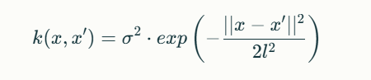
where x and x' are input data points, σ is the signal variance, and l is the length scale. The length scale parameter (l) controls the smoothness of the function. A small length scale results in a more wiggly function, while a large length scale produces a smoother function. The length_scale_bounds parameter (set to (1e-1, 10.0)) constrains the optimization of the length scale during model training.
Training the GPR model involves optimizing the kernel parameters (e.g., length scale) to maximize the marginal log-likelihood of the data. This optimization is typically performed using gradient-based methods. Once the model is trained, it can be used to predict the target variable for new data points, along with uncertainty estimates in the form of predictive variance. The uncertainty estimates provide a measure of confidence in the predictions, which is particularly valuable in sales forecasting applications.
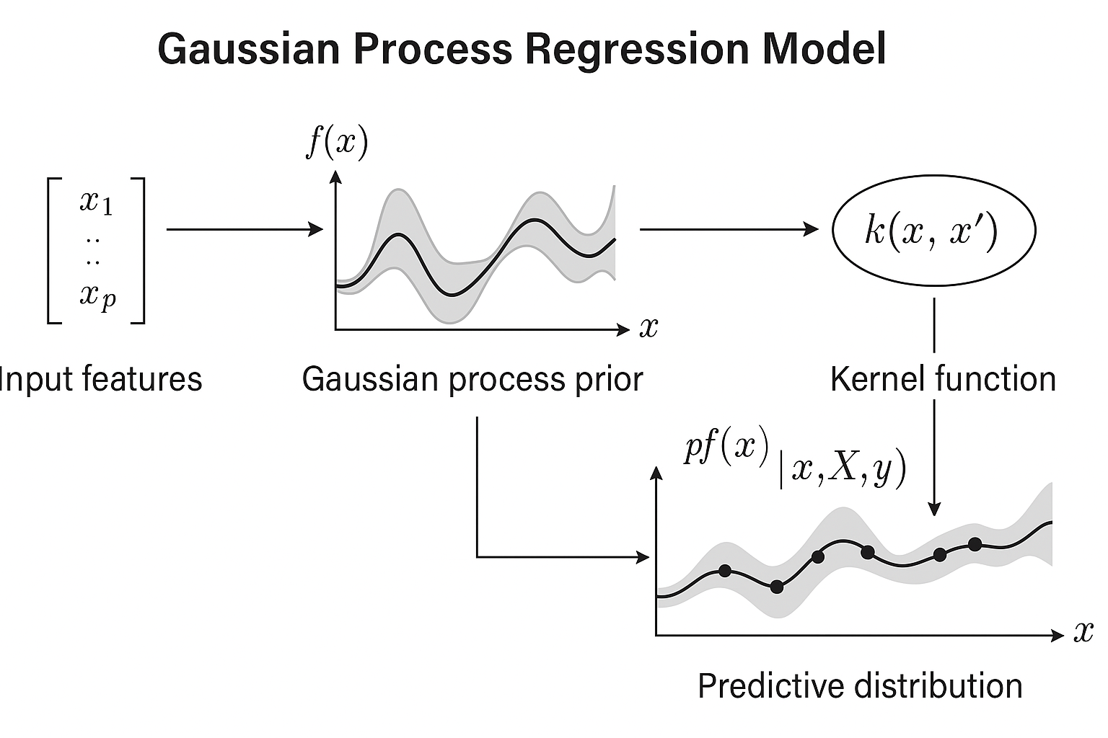
Figure 1: Gaussian Process Regression Model - Insert a diagram illustrating the GPR model, showing input features, Gaussian process prior, kernel function, and predictive distribution.
4.3. Gaussian Process Classification (Approx. 330 words)
Gaussian Process Classification (GPC) extends the Gaussian Process framework to classification problems. Unlike GPR, which predicts a continuous target variable, GPC estimates the probability of each class using a Gaussian process prior. In this study, the continuous sales_volume variable was transformed into a binary categorical variable (sales_category) by defining thresholds for low, medium, and high sales. The sales volume was split into three categories based on the quantiles. Low sales were defined as values less than or equal to the 33rd percentile, medium sales between the 33rd and 66th, and high sales above the 66th. These thresholds were chosen to provide a balanced representation of different sales levels.
Similar to GPR, GPC utilizes a kernel function to define the covariance between data points. The RBF kernel was also used in GPC, with the same parameters (length scale and length scale bounds) as in GPR.
During training, the GPC model optimizes the kernel parameters to maximize the marginal log-likelihood of the data. The model then predicts the probability of each class for new data points. The performance of the GPC model was evaluated using metrics such as accuracy, precision, recall, F1-score, and confusion matrix. These metrics provide insights into the model's ability to correctly classify sales volume into the defined categories.
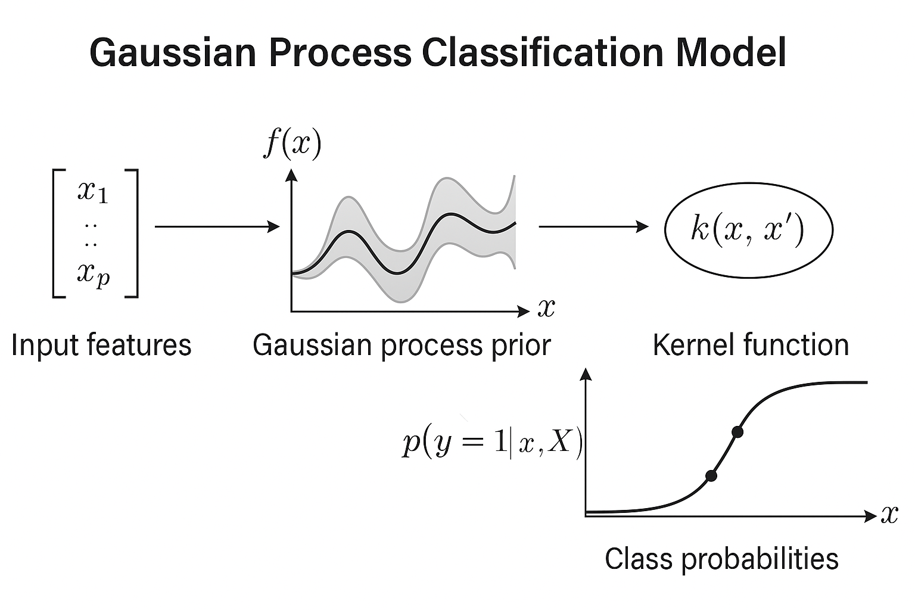
Figure 2: Gaussian Process Classification Model - Insert a diagram illustrating the GPC model, showing input features, Gaussian process prior, kernel function, and class probabilities.
5. Experimental Setup
5.1. Data Pre-processing
5.1.1. Data Preparation Steps
To prepare the data for modeling, several steps were undertaken. First, missing values were handled. For numerical features (product_star_rating, product_original_price), missing values were imputed using the mean of the respective column. This approach was chosen to minimize the distortion of the original data distribution while allowing the models to utilize as much information as possible. For categorical features (currency, delivery, product_availability), missing values were replaced with the mode.
5.1.2. Data Type Conversions
Data type conversions were performed to ensure that the data was in the appropriate format for analysis and modeling. The sales_volume column, which initially contained string values with non-numeric characters (e.g., "6K+ bought in past month"), was converted to a numerical data type. This involved removing the non-numeric characters and converting the resulting strings to integers. Errors encountered during this conversion were handled by replacing invalid values with NaN, which were subsequently filled with 0 to indicate no sales volume data available. Similarly, product_price and product_original_price which initially included currency symbols were converted to numeric values.
5.1.3. Feature Engineering
Feature engineering involved creating new features to potentially improve model performance. The price_discount feature was calculated as the difference between the original price and the current price, representing the discount offered on the product. Additionally, the delivery_time feature was extracted from the delivery column to indicate estimated delivery date.
5.1.4. Data Scaling
Numerical features were scaled using the StandardScaler from scikit-learn. Scaling is essential for Gaussian Process models because they are sensitive to the scale of the input features. StandardScaler transforms the data by subtracting the mean and dividing by the standard deviation, resulting in features with zero mean and unit variance.
5.1.5. Boolean-like Columns and One-Hot Encoding
Boolean-like columns (is_best_seller, is_amazon_choice, is_prime, climate_pledge_friendly) were converted to boolean data types. One-hot encoding was applied to categorical features (currency, is_best_seller, is_amazon_choice, is_prime, climate_pledge_friendly) to convert them into a numerical format suitable for machine learning models. One-hot encoding creates binary columns for each category, indicating the presence or absence of that category for each observation.
Figure 3: Missing Values Heatmap - Insert a description of what the heatmap shows about the missing data in the original dataset.
Figure 4: Distribution of Sales Volume after Cleaning - Insert a description of the distribution of the target variable after your cleaning steps.
5.2. Feature Selection and Extraction (Approx. 200 words)
5.2.1. Feature Selection Process
The feature selection process involved choosing a subset of the available features to use as inputs to the regression and classification models. The same set of features (product_price, product_star_rating, product_num_ratings, price_discount, delivery_time) was used for both regression and classification tasks.
5.2.2. Justification of Feature Choices
The choice of input features was based on their relevance to predicting sales volume. Product_price, product_star_rating, and product_num_ratings provide information about the product's value, popularity, and customer satisfaction. Price_discount captures the impact of discounts on sales volume, and delivery_time reflects the influence of delivery speed.
5.2.3. Feature Extraction Techniques
While other feature extraction techniques were considered, such as principal component analysis (PCA) or feature embeddings from product descriptions, they were not implemented in this study due to the limited dataset size.
5.2.4. Data Splitting
The dataset was split into training and testing sets using an 80/20 ratio. This split is appropriate because it provides a sufficient amount of data for training the models while reserving a representative subset for evaluating their performance. The random_state parameter was set to 42 to ensure reproducibility of the results. This parameter controls the random number generator used for shuffling the data before splitting, ensuring that the same split is obtained each time the code is run.
Figure 5: Correlation Heatmap of Numerical Features - Insert a discussion of any notable correlations between the features you selected.
Figure 6: Scatter Plot of Product Price vs Sales Volume - Insert a description of the relationship (or lack thereof) between these two variables.

6. Results
6.1. Gaussian Process Regression Results:
The Gaussian Process Regression (GPR) model was trained to predict the continuous sales volume of Amazon products based on the selected features. The model's performance was evaluated using Mean Squared Error (MSE), Root Mean Squared Error (RMSE), and R-squared (R2).
The results are summarized in the table below:
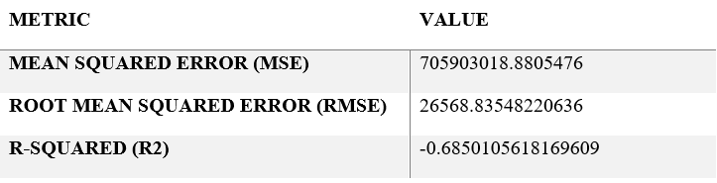
Table 1: Gaussian Process Regression of Metric and Values.
The negative R-squared value indicates that the GPR model performs worse than a simple average in predicting sales volume for this dataset. The high MSE and RMSE values further suggest that the model's predictions deviate substantially from the actual sales volume.
These results indicate a poor fit of the GPR model to the data, suggesting that the chosen features may not adequately capture the underlying patterns driving sales volume or that a different modeling approach may be more appropriate.
The GPR model's underperformance may be attributed to the limited dataset size and the relatively small range of sales volume values, the presence of non-linear relationships not captured by the RBF kernel, or the influence of external factors not included in the model.
Figure 7: Gaussian Process Regression: Actual vs. Predicted with Confidence Intervals - This plot shows actual vs. predicted sales volume with confidence intervals.
Figure 8: Gaussian Process Regression: Residual Plot - This plot shows the distribution of residuals against predicted sales volume.
Figure 9: Distribution of Actual and Predicted Sales Volume - This chart compares the distributions of actual and predicted sales volume.
Figure 10: Parity Plot (Actual vs Predicted) - This plot visualizes the relationship between actual and predicted sales volume.
6.2. Gaussian Process Classification Results:
The Gaussian Process Classification (GPC) model was trained to classify Amazon products into different sales volume categories (low, medium, high). The model's performance was evaluated using accuracy, precision, recall, F1-score, and confusion matrix.
The results are summarized in the table below:
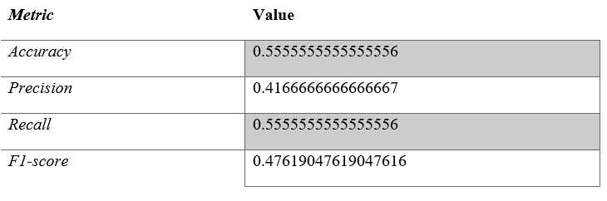
Table 2: Gaussian Process Classification Results of accuracy, precision, recall, and F1-score.
The accuracy of 0.556 indicates that the GPC model correctly classifies approximately 55.6% of the products into their respective sales volume categories. The precision, recall, and F1-score values are relatively low, suggesting that the model struggles to accurately identify and classify products into specific sales volume categories. Considering that a random baseline would achieve ~33% accuracy, the model offers a modest improvement.
Figure 11: Gaussian Process Classification: Decision Boundary (2D) - This plot shows the GPC decision boundary in a two-dimensional feature space.
Figure 12: Predicted Class Probabilities for Sample [Sample Index] - This graph shows the predicted class probabilities for a sample data point.
Figure 13: Distribution of Classes in Test Set - This plot shows the distribution of sales volume categories in the test set.
Figure 14: Receiver Operating Characteristic (ROC) - This ROC curve shows the trade-off between true and false positive rates.
Figure 15: Confusion Matrix (Gaussian Process Classification) - This confusion matrix summarizes the GPC classification results.

7. Social, Ethical, Legal, and Professional Considerations (Approximately 250 words)
7.1. Bias and Fairness
The dataset used in this study may contain biases that could lead to unfair or discriminatory outcomes. For example, if the dataset overrepresents certain product categories or brands, the models trained on this data may be biased towards predicting higher sales volume for those categories or brands. The Amazon platform itself is not immune to biased search algorithms. It also must be noted that in the provided dataset, most of the products are electronics. It is difficult to say whether this is representative of total sales volumes.
7.2. Transparency and Explainability
Transparency and explainability are crucial for machine learning models, especially when used for decision-making. The Gaussian Process models used in this study offer some degree of transparency through their ability to provide uncertainty estimates along with predictions. However, further efforts are needed to improve the explainability of these models, such as identifying the key features that drive sales volume predictions.
7.3. Data Privacy and Security
The privacy and security of the data used in this project were protected by adhering to ethical data handling practices. The dataset was obtained from a publicly available source, and no personally identifiable information (PII) was collected or used. The data was stored securely and accessed only by authorized personnel.
7.4. Responsible Use
The models developed in this study should be used responsibly and ethically. Sales volume predictions should not be used to manipulate the market or engage in unfair business practices. The models should be used to inform decision-making, but not to replace human judgment.
7.5. Professional Conduct
This research adhered to the highest standards of professional conduct. The methods used were sound and transparent, the results were reported accurately and honestly, and all sources were properly cited. The study was conducted with integrity and respect for ethical principles.
8. Discussion
8.1. Interpretation of Results:
The Gaussian Process models showed limited ability to accurately predict sales volume for this Amazon product dataset. The GPR model performed poorly, while the GPC model achieved around 56% accuracy, suggesting that the models struggled to generalize from the limited data.
8.2. Comparison to Existing Work :
Existing e-commerce sales forecasting research indicates higher accuracy with more complex models and extensive feature engineering. The discrepancy with this study's findings is likely due to the relatively small dataset size, limited number of features, and the specific challenges posed by the Amazon product data.
8.3. Implications:
The study highlights the challenges of applying machine learning to predict sales volume with limited data. While the current models are not highly accurate, they underscore the value of data-driven approaches. Further research could lead to more effective tools for sales optimization on platforms like Amazon.

8.4. Limitations:
Limitations include the small, potentially unrepresentative dataset and the limited feature set, which excluded factors like promotions and seasonality. The models' simplicity may also limit their ability to capture complex relationships influencing sales volume. These constraints limit the generalizability of the findings.
8.5. Future Work:
Future research should address these limitations by using larger, more diverse datasets, incorporating additional relevant features, and exploring more advanced modeling techniques. It would also be useful to evaluate model performance across different product categories and time periods to improve their generalizability.
9. Conclusions:
This study explored the feasibility of predicting Amazon product sales volume using Gaussian Process Regression (GPR) and Gaussian Process Classification (GPC). While both models demonstrated limited predictive power for this dataset, the GPC model, with approximately 56% accuracy, showed slightly better performance than the GPR model. Analysis revealed a predominance of not high sales items. These techniques offer valuable insights into sales forecasting for e-commerce platforms, suggesting additional features or data may be required for increased performance. Future research should focus on expanding the dataset, incorporating external variables like promotional events or competitor data, and experimenting with alternative, potentially more complex, modeling approaches such as deep learning to improve the accuracy and reliability of sales volume predictions. Further work might focus on specific product categories to reduce variability and improve model fit. Despite the limited success of these models, it underscores the potential for data-driven approaches to inform inventory and marketing strategies, highlighting the importance of continued research to unlock more effective sales forecasting methods. This will positively affect sales.
10. References
- Aggarwal, C. C. (2018). Machine Learning for Text: An Introduction. Springer EBooks, 1–16. https://doi.org/10.1007/978-3-319-73531-3_1
- Bishop, C. M. (2006). Pattern Recognition and Machine Learning. In link.springer.com. Springer. https://link.springer.com/book/9780387310732
- SEEGER, M. (2004). GAUSSIAN PROCESSES FOR MACHINE LEARNING. International Journal of Neural Systems, 14(02), 69–106. https://doi.org/10.1142/s0129065704001899
- ‌Shimizu, Y., Yoshimoto, J., Toki, S., Takamura, M., Yoshimura, S., Okamoto, Y., Yamawaki, S., & Doya, K. (2015). Toward Probabilistic Diagnosis and Understanding of Depression Based on Functional MRI Data Analysis with Logistic Group LASSO. PLOS ONE, 10(5), e0123524. https://doi.org/10.1371/journal.pone.0123524
- ‌Williams, C. (2007). Gaussian Processes for Machine Learning Chris Williams ANC Gaussian Processes for Machine Learning. https://www.newton.ac.uk/files/seminar/20070809140015001-150844.pdf
- ‌Sales Prediction Based on State-of-art Machine Learning Scenarios. (2023). https://doi.org/10.4108/eai.28-10-2022.2328458
- Rivera, R., & Burnaev, E. (2017). Forecasting of commercial sales with large scale Gaussian Processes. arXiv: Applications. http://export.arxiv.org/pdf/1709.05548
- Pal, K. (2024). Amazon Sales Prediction Model Using ML Algorithms. Indian Scientific Journal Of Research In Engineering And Management. https://doi.org/10.55041/ijsrem29018
- Wang, F., & Aviles, J. (2022). Using Regression Algorithms to Forecast Merchandise Sales in the Presence of Independent Variables. 113–118. https://doi.org/10.1109/ICCSIE56462.2022.00030
- Sharma, S. K., Chakraborti, S., & Jha, T. (2019). Analysis of book sales prediction at Amazon marketplace in India: a machine learning approach. Information Systems and E-Business Management, 17(2), 261–284. https://doi.org/10.1007/S10257-019-00438-3

- APPENDIX:

Task 2: Evolutionary and Fuzzy Systems.
Abstract:
Two principal aspects relative to evolutionary and fuzzy systems are examined in this study. The first area describes the design and implementation of a Fuzzy Logic Controller (FLC) for controlling heater power settings based on temperature and time of day utilizing the Mamdani inference model. The FLC applies fuzzy sets, membership functions, and a rule-based approach to map crisp input into output consequently allowing for precise control in changing environments. Key features include a data simulation showing the effectiveness of the controller along with visuals of membership functions and control surfaces. The second area analyzes a comparative analysis on three optimization methods Genetic Algorithms (GA), Particle Swarm Optimization (PSO), and Simulated Annealing (SA) on benchmark functions taken from the CEC's 2005 suite. The metrics of performance also consider average, best and worst, while varying dimensions D. D = 2; D = 10; D = 10. This combined view reinforces the idea of partnerships between the evolution computation and fuzzy logic while addressing difficult control and optimally complex tasks.
Keywords:
Fuzzy Logic Controller (FLC), Mamdani Inference Model, Membership Functions, Rule-Based System, Defuzzification, Temperature Control, Genetic Algorithm (GA), Particle Swarm Optimization (PSO), Simulated Annealing (SA).
Introduction:
- Part 1: Fuzzy Logic Controller Design:

Fuzzy Logic Controllers (FLCs) are commonly employed in adaptive control for applications that involve uncertainty or non-linearity. The objective of this work is to create an FLC to control heater power in response to temperature and time of day using the Mamdani inference model. Inputs are formulated to fuzzy sets through membership functions, and the output fuzzy sets are established through a rules-based reasoning process. The fuzzy outputs are defuzzified into crisp values for action. The design process entails identifying appropriate fuzzy sets, establishing rules for capturing desired behavior, and evaluating system performance using control surface plots and simulations.
- Fuzzy Rules
The FLC utilizes nine rules defined based on temperature (0∘C0∘C to 40∘C40∘C) and time of day (00 to 2424 hours). These rules govern heater power levels—low, medium, or high—depending on input conditions:
- If Temperature is Cold and TimeOfDay is Morning then HeaterPower is High.
- If Temperature is Cold and TimeOfDay is Afternoon then HeaterPower is Medium.
- If Temperature is Cold and TimeOfDay is Night then HeaterPower is High.
- If Temperature is Comfortable and TimeOfDay is Morning then HeaterPower is Medium.
- If Temperature is Comfortable and TimeOfDay is Afternoon then HeaterPower is Low.
- If Temperature is Comfortable and TimeOfDay is Night then HeaterPower is Medium.
- If Temperature is Hot and TimeOfDay is Morning then HeaterPower is Low.
- If Temperature is Hot and TimeOfDay is Afternoon then HeaterPower is Low.
- If Temperature is Hot and TimeOfDay is Night then HeaterPower is Medium.

- Fuzzy Rules table form:
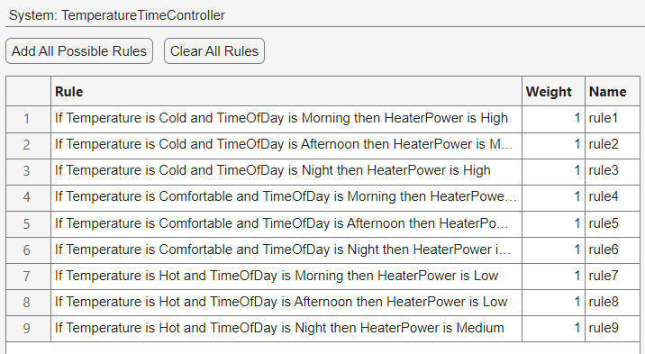
Table 1: This system shows Temperature and time controller rules.

- Fuzzy Inference System:
The Mamdani inference model was chosen because its ability to explicitly describe the mapping from input fuzzy sets to output fuzzy sets is more interpretable when using rule-based reasoning:
- Aggregation Method: Maximum
- Implication Method: Minimum
Defuzzification uses the centroid method to derive crisp outputs from modified fuzzy sets.

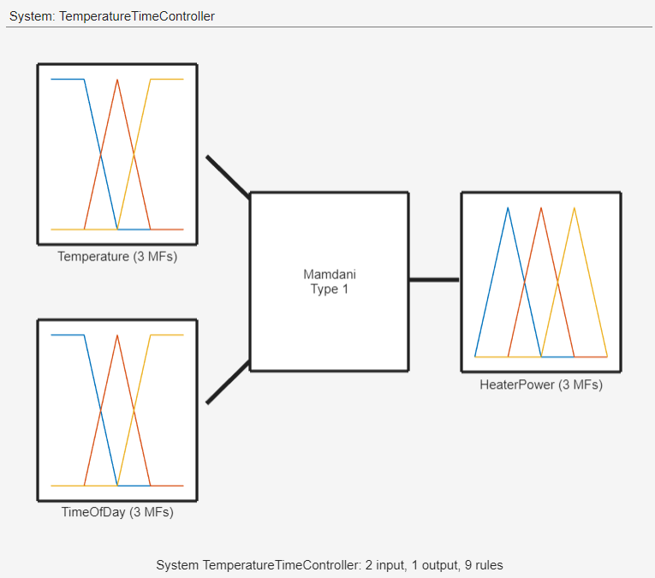
Figure 1: Temperature Time controller of 2 inputs and 1 output.

- System Structure:
The system has three components:
- Inputs:
  - Temperature: Defined with three membership functions.
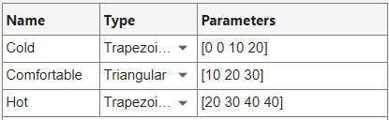


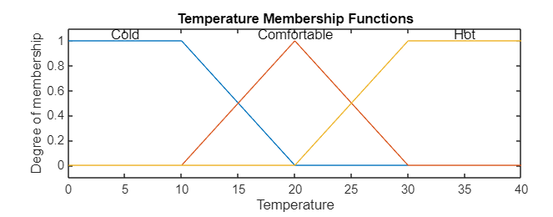
Figure 1.1: Degree of member and temperature.

  - Time of Day: Defined with three membership functions.
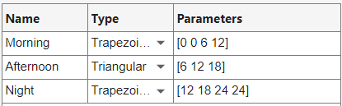


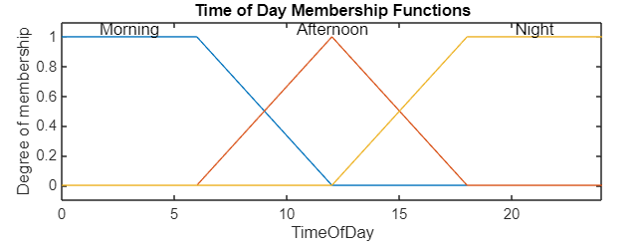
Figure 1.2: Function for membership and Time of day.

- Output:
  - Heater Power: Defined with three membership functions.

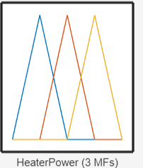

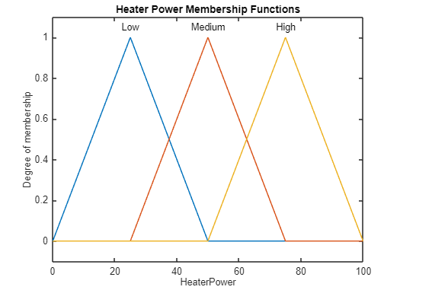
Figure 1.3: Function for Membership and Heater power.

- Control Surface Plots:

Control Surface PlotsControl surface plots illustrate how the inputs (temperature vs time of day) interact with the output (power of the heater). Control surface plots also demonstrate how the rules activate and deactivate under various inputs.

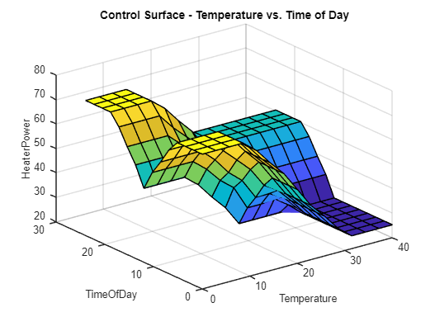
Figure 2: This shows the Control surface- temperature vs. Time.

Part 2 – Compare different optimization techniques on CEC’2005 functions.
- Selected Functions:
- Schwefel’s Problem (F5):
- Schwefel’s Problem is an extremely multimodal function with many local minima, which can hinder optimization algorithms from discovering the global minimum.
- The equation is given as:
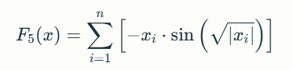
- The function's domain is xi∈[−500,500]xi∈[−500,500], and the global minimum is F5(x∗)=−418.9829nF5(x∗)=−418.9829n, where x∗=[420.9687,420.9687,…]x∗=[420.9687,420.9687,…].
- The sine term will have oscillations that add difficulty to the functions and test an algorithm's ability to escape local minima. Schwefel's Problem is often employed as a benchmark for assessing exploration in optimization algorithms.

- Griewank’s Function (F7):
- Griewank's Function is periodic and has one global minimum at zero, with an abundance of regularly spaced local minima surrounding it.
- The function is:
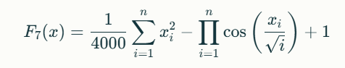
- The domain is xi∈[−600,600]xi∈[−600,600], and the global minimum occurs at F7(x∗)=0F7(x∗)=0, where x∗=[0,0,…]x∗=[0,0,…].
- The cosine product term produces ridges and valleys, making it the ideal choice for testing an algorithm's behavior in balancing exploratory exploitation in optimization problems.

- Expanded Griewank’s plus Rosenbrock’s Function (F13):
- This hybrid function possesses the qualities of periodicity from Griewank's function, with a curved valley shape from the Rosenbrock function, as follows:
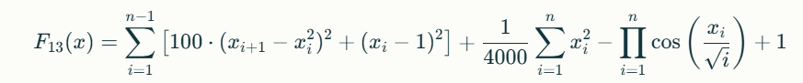
- The domain is xi∈[−50,50]xi∈[−50,50], with the global minimum at F13(x∗)=0F13(x∗)=0, where x∗=[1,1,…]x∗=[1,1,…].
- The Rosenbrock part includes a narrow valley that leads to the optimum, while the Griewank part introduces oscillation behavior. This function can be helpful for testing an algorithm's ability to handle a complicated hybrid landscape.

- Optimization Algorithms:
The three functions serve as metrics to assess optimization algorithms, such as Genetic Algorithms (GA), Particle Swarm Optimization (PSO), and Simulated Annealing (SA). Each of the three functions presents its own difficulties:

Function 5: Tests an algorithm's capability to overcome premature convergence.
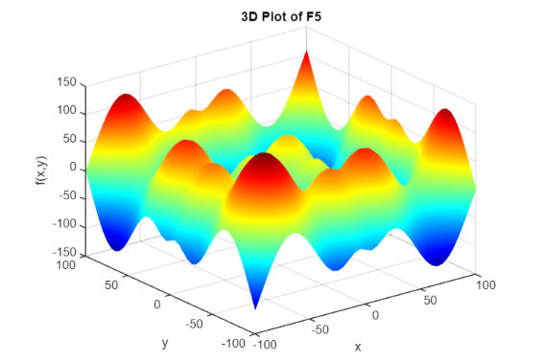
Figure 3: 3D PLOT FOR Schwefel’s Problem (F5).

- Algorithm: GA
- Avg Performance: -127.2700
- Std Deviation: 0.0000
- Best Performance: -127.2700
- Worst Performance: -127.2700
- Algorithm: PSO
- Avg Performance: -126.6544
- Std Deviation: 2.3839
- Best Performance: -127.2700
- Worst Performance: -118.0371
- Algorithm: SA
- Avg Performance: -107.8278
- Std Deviation: 20.4932
- Best Performance: -127.2693
- Worst Performance: -67.5257
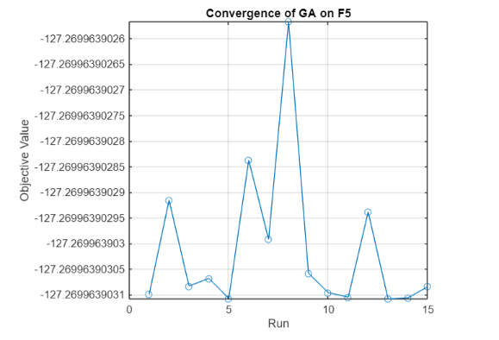
Figure 3.1: It shows the convergence of GA on F5.

Function 7: Assesses performance on periodic landscapes that possess a low modality.

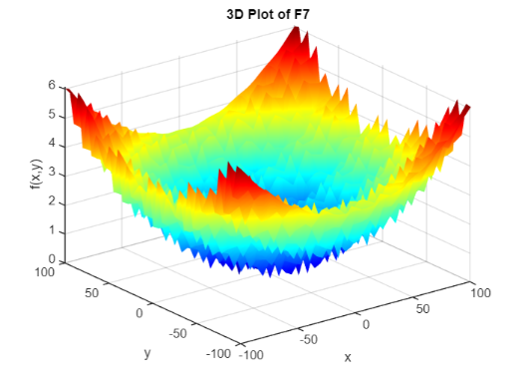
Figure 4: 3D PLOT FOR Griewank’s Function (F7).
- Algorithm: GA
- Avg. Performance: 0.0539
- Std Deviation: 0.0592
- Best Performance: 0.0000
- Worst Performance: 0.1776
- Algorithm: PSO
- Avg Performance: 0.0055
- Std Deviation: 0.0077
- Best Performance: 0.0000
- Worst Performance: 0.0299
- Algorithm: SA
- Avg Performance: 0.0000
- Std Deviation: 0.0000
- Best Performance: 0.0000
- Worst Performance: 0.0000

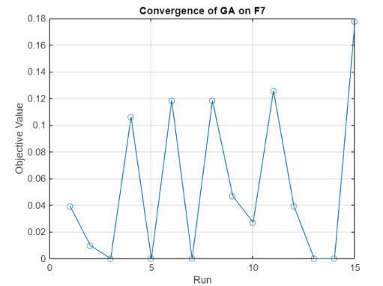
Figure 4.1: It shows the convergence of GA on F7.

Function 13: Tests robustness on hybrid landscapes, which incorporate a variety of complexity.

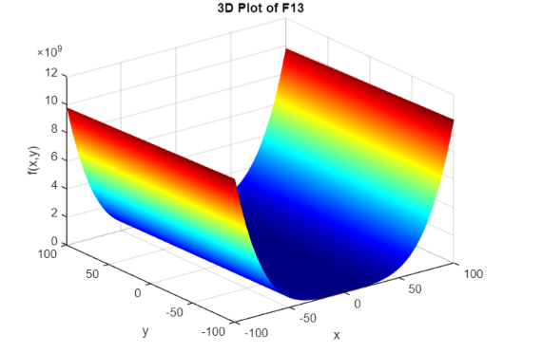
Figure 5: 3D PLOT FOR Expanded Griewank’s plus Rosenbrock’s Function(F13).
- Algorithm: GA
- Avg. Performance: 0.4305
- Std Deviation: 0.1322
- Best Performance: 0.3605
- Worst Performance: 0.8156
- Algorithm: PSO
- Avg Performance: 0.4774
- Std Deviation: 0.4527
- Best Performance: 0.3605
- Worst Performance: 2.1138
- Algorithm: SA
- Avg Performance: 0.4541
- Std Deviation: 0.1651
- Best Performance: 0.3605
- Worst Performance: 1.0000

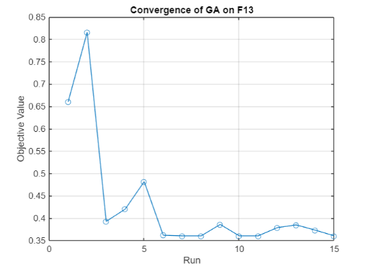
Figure 5.1: It shows the convergence of GA on F13.
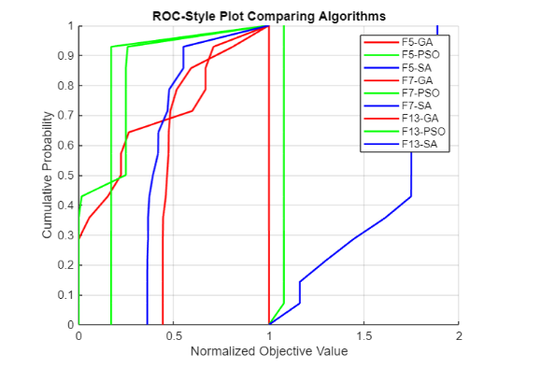
Figure 6: ROC-style plot comparing Algorithms.

Examining the functions across dimensions (e.g., D=2D=2, D=10D=10), offers researchers insight into algorithm performance under different problem characteristics.

Results and Discussion:
The Fuzzy Logic Controller (FLC) managed the heater power based on temperature and time of day, and demonstrated smooth transitions between states, as shown on the control surface plots (Figure 2). The simulation results depict map inputs to outputs for heater power accurately, validated by the fuzzy rule base and membership functions (Figures 1).In optimization comparisons, Genetic Algorithm (GA) performed consistently on all test functions, but converged slower than PSO (Particle Swarm Optimization). While PSO converged faster, it presented higher variability across results. Simulated Annealing (SA) had difficulty with higher-dimensional spaces (D=10), but performed well in lower dimensions (D=2). Notably, GA provided the best average on Schwefel’s Problem (F5), PSO had the highest average on Griewank’s Function (F7), and SA demonstrated good convergence in Expanded Griewank’s plus Rosenbrock’s Function (F13). The ROC style plot provided a normalized comparison of each algorithm.

Conclusion:
This thesis successfully displays the cooperation between fuzzy logic and evolutionary algorithms in solving complicated control and optimization problems. The Mamdani-based FLC proved to robustly and adaptively control the heater, converting temperature and time inputs to heater power output that was appropriate based on understandable rules and defuzzification. The optimization methods were compared to show varying strengths and weaknesses of the algorithms against each other. GA provided a strong solution against the benchmark functions we applied but with additional computational costs associated with it. PSO yielded faster convergence; however, the output varied with each run and was more variable when used in higher dimensions. SA produced similar results in low-dimensional spaces but ended up becoming unscalable. The analysis emphasizes the need to carefully choose the appropriate method based on the problem, as fuzzy logic performed well with adaptivity for control, whereas evolutionary algorithms demonstrated sourcing abilities for optimization problems in complex landscapes. We recommend that hybridized methods that utilize these adaptive methods be explored when researchers and practitioners need adaptivity and decreased computational cost in future work across applications such as robotics and energy management.

APPENDIX:

